Python installation from www.python.org

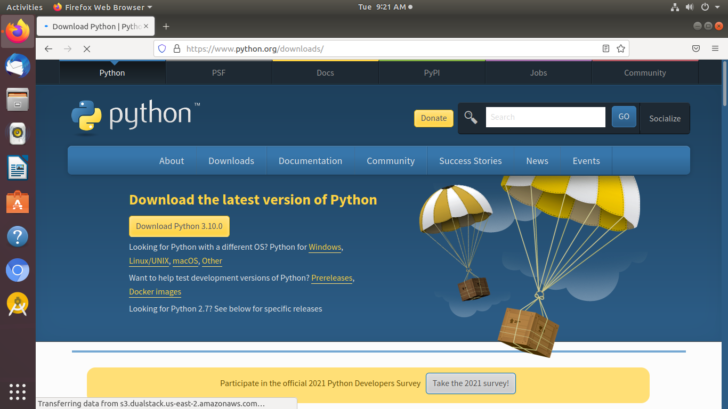

Step 1: Select Version of Python to Install.
- Step 2: Download Python Executable Installer.
- Step 3: Run Executable Installer.
- Step 4: Verify Python Was Installed On Windows.
- Step 5: Verify Pip Was Installed.
- Step 6: Add Python Path to Environment Variables (Optional)
- Step 7: Install virtualnv (Optional)


pycharm IDE installation

1.Download PyCharm from the JetBrains website.

2.After running the installer, select the installation location. The most common location is in our Program Files directory, but this can be changed to an alternative location if needed, but this is usually unnecessary.

3.include the option to add a desktop shortcut, updating your path to include PyCharm launcher along with any associating file types, and a context menu. You can see below the choices I have selected for my installation.

4.The next step is to choose your start menu folder location, for a quick reference from your desktop start page.

Python Programs

1.Generate a list of 4-digits no.s in a given range with all their digits even and the number is a perfect square.

Source_code

import math

for i in range(1000,10000):

num = int(math.sqrt(i))

if num*num == i:

n=i

while n!=0:

r=n%10

n=n/10

if r%2!=0:break

else:print(i)

Screen_shot

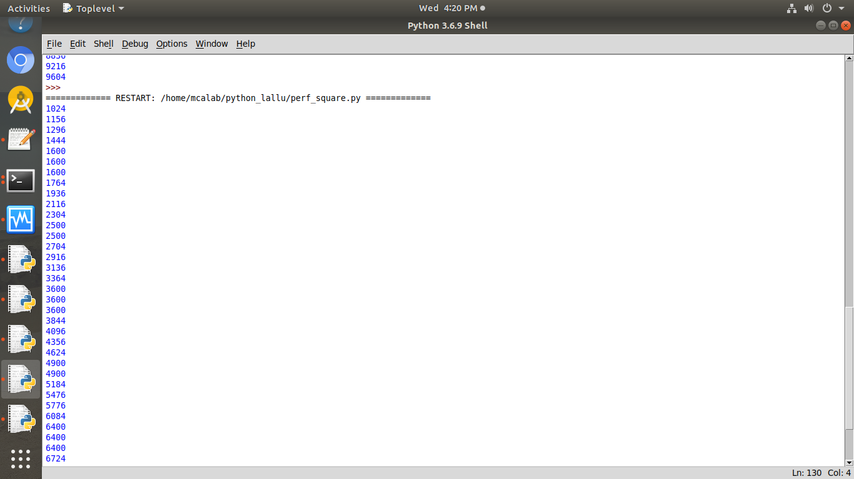

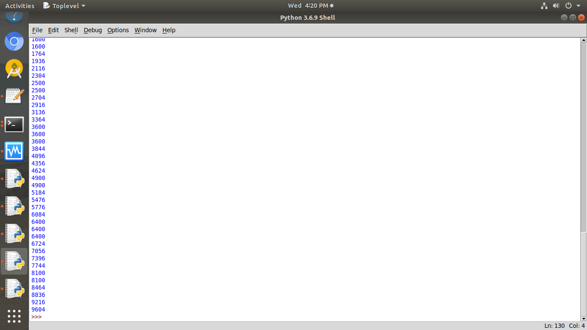

2.Display the given pattern with step number accepted from now:

1
2 4
3 6 9
4 8 12 16

Source_code

n = int(input("enter the step size:"))
for i in range(1,n+1):
k=i
for j in range(1,i+1):
print(k,end='')
k+=i
print()

Screen_shot

